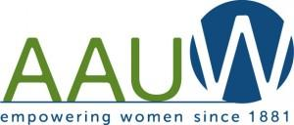 The Pipeline
Riverside-Moreno Valley- San Gorgonio Branch of AAUW
September & October 2019
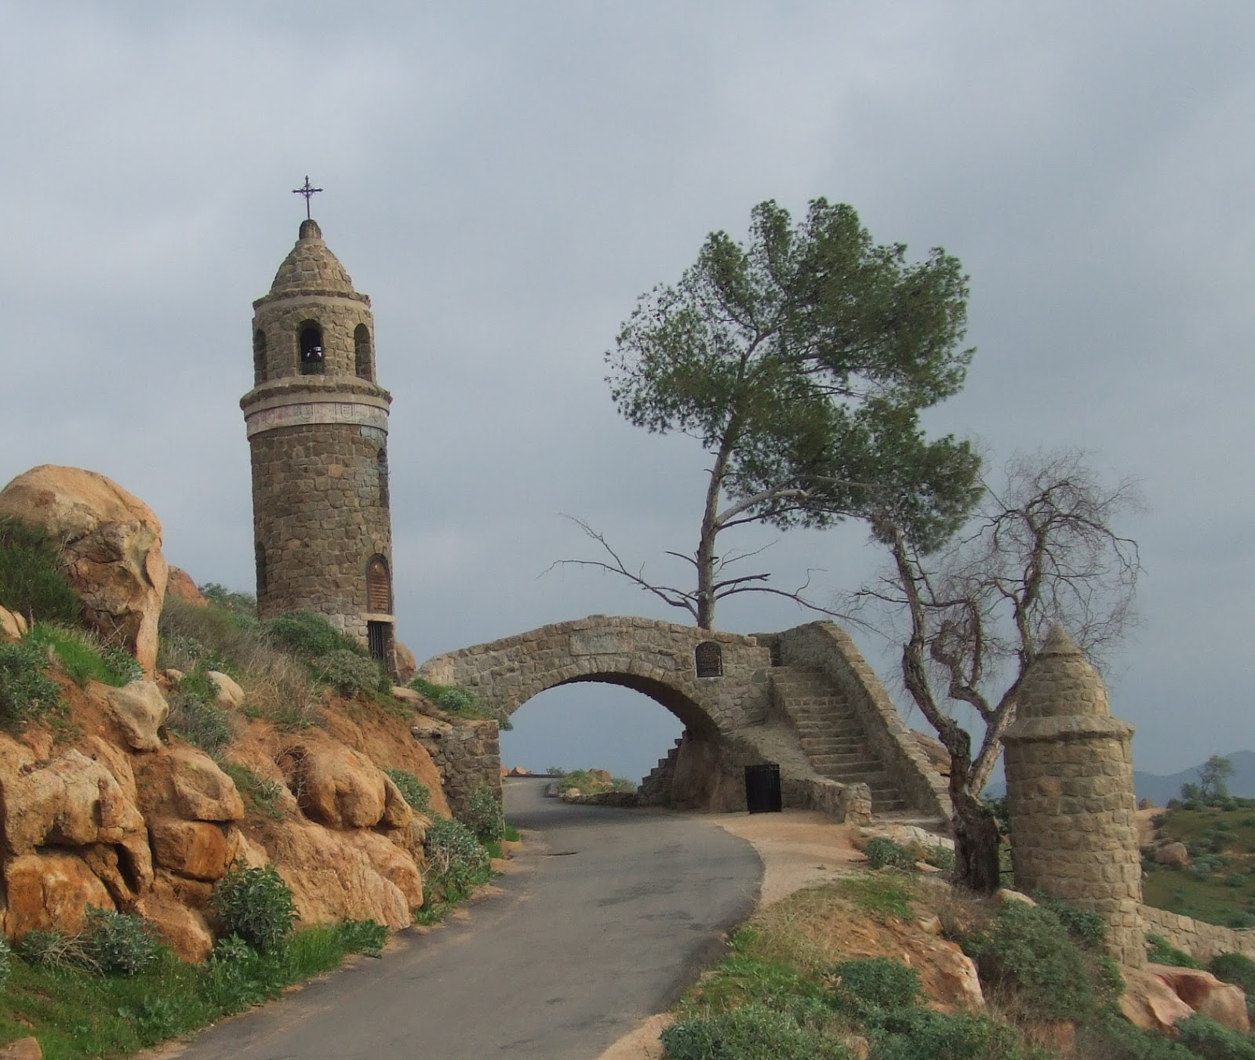Do you know where this is?

Annual Post-Tech Trek Reception & General Meeting

Saturday, September 7, 2019 at 10:00 AM at Altura Credit Union Corporate Center, 2847 Campus, Riverside 92507
Come one, come all

Many of the Riverside and Moreno Valley Seventh Grade girls who were sponsored by our AAUW chapter and attended the University of California San Diego or the Whittier College campus will be there with their families and will tell stories of their adventures. Here are excerpts from thank you notes written by the girls who attended this year:
Moreno Valley: “This is a life-time opportunity and I am so grateful. We took a trip to Viasat and it was so cool. We got a chance to go to Scripps Institute of Oceanography. My core class was engineering … and our main project was building a house that can survive an earthquake. I wouldn’t have done these amazing things and experienced these life-time moments if it wasn’t for you.” Yuritzy Huerta Salcedo
“I want to thank you for giving me this opportunity to come to Tech Trek and learn new things. I have a hard time making friends but these people here are super friendly and kind. I have had so much fun staying here. I love my dorm mom. She is just amazing. I really liked my core class, math. We made a rocket from an old canister.” Matavi Dypha
“Thank you for giving me this chance to come to Tech Trek. This opportunity has made an impact in my future. At first I wanted to be a criminal lawyer but now I am considering Marine Biology…after talking to some amazing women that study at the Scripps Institute. I am very grateful.” Leslie Alcantara-Palacios
“…when I grow up I want to be (either)a mechanical engineer, structural engineer, or medical examiner. I liked camp for many reasons, including making new friends and …it has inspired me to pursue one of these three careers. It was so much fun experiencing how college students live in the dorm rooms. Thank you for giving this opportunity to go to camp.” Kelly Rivera
“I really enjoyed my time here at camp. In my physics class we did the Rube Goldberg (activity) and that was so amazing. We were one of the few groups that completed our challenge. We went to the Scripps Institute (which) was really fun. I learned about a lot of careers that I would like to pursue in the future. I would like to thank you so much for choosing me.” Ashley Gallegos
“Thank you for sending me to Tech Trek. It was the most awesome experience ever. I had the best learning experience learning about chemicals and molecules in my chemistry core class. I really enjoyed going to the Viasat field trip and learning about women engineers. It was one of the most terrific experiences I have ever had. Thank you so much for sending me to Tech Trek.” Miranda Low-Urins
“Thank you for picking me. I had the best time being at San Diego for Tech Trek. I met a lot of great people.” Rubi Perez
Riverside: Thank you… I had so much fun, I wish I could have stayed longer! I had engineering design as my core class. I had fun building bridges and solving challenges. I enjoyed working as a team and communicating with each other on how to build a bridge. Professional women’s night was wonderful. I got to meet … Jessica Bussjaeyer, a design engineer for rocket ships. I got to learn new things on how spaceships work. Overall, my favorite part out of everything was working as a team.” Jennifer Diego

NEXT GENERAL MEETING

October 12, 2019 at 10:00 AM at Riverside Library, Arlington Branch, 9556 Magnolia, Riverside 92503.

Speaker: Tom Jameson who speak about Continuation School in Riverside. More details to follow.
Come one, come all

Board Meetings - All are welcome! 10 AM first Monday of every month at Altura Credit Union, 3451 14th Street, Riverside.
September 30, 201
October 7

Afternoon Book Club - At home of Kathye Crumley, 2982 Rockwood Dr, Riverside CA 92503 , (951) 686-7233 the first Thursday of every month at 1 PM.
Sept 5 -The Library Book La Fire by Susan Orlean
Oct 3 - The Island of Sea Women by Lisa See .

Evening Book Club - at rotating location Usually the third Thursday of every month at 7 PM
Sept 18 - (Wed) The Other Americans by Laila Lalami at the home of Carole Nagengast, 26410 Ironwood Ave, Moreno Valley, (951) 242-2791.
Oct 17 - In the Country of Women by Susan Straight at the home of Erika Britton, 5700 Via Sotelo, Riverside, (909) 633-5746.

Great Decisions – At the home of Charlotte and Mike Lucey, 1512 Century Ave, Riverside, (951) 776-2887 the fourth Thursday of every month. Cost of book & video is $35 per year.
Sep 26 and October 24th

Virginia Blumenthal-Aug. 2; Erika Britton-Aug. 10; Carrie Garrett- Aug 18; Christine Gailey-Aug. 21; Carlease Chandler-Sept 8; Marilyn Puckett-Sept 26; Ellie Bennett-Sept 3; Aki Caszatt-Sept 30, Charlotte Lucey-Oct 2; Beverly Nickerson- Oct 2; Leticia Rosales-Oct 6; Jennifer Carson- Oct 14; Muriel Berger- Oct 24.

Book Donations: August, 2019

In the past the AAUW chapter has gathered and donated books to Grade “K” and “TK” classes in elementary schools in Riverside USD, Moreno Valley USD, and the Alvord USD. Eleven schools, counting this year, have benefited from our generosity. So many people have donated over the past few years that we decided to benefit two schools this year. Liberty Elementary School and Fremont schools, both located in Riverside, were chosen to receive books. About 450 new and very gently used books were collected from members of this chapter and given to the “K” and ‘TK” teachers on Friday, August 9th. We could not begin to put a monetary value on the books, but surely it would be at least $1000. Thanks to the Riverside chapter of AARP, which has made us the beneficiaries of one of their monthly campaigns and promises to do so again in the future and to all those individuals – too many to name - who went all out this year. Ruthann (Millie) Mlcoch made a “Read Bear” for each of the 10 K and TK classes. (See photo below). The idea is that children learn to read to “their” class bear. All the teachers and administrators at Fremont and Liberty were happy to receive our gift and had great ideas about how they would use them. Several members of our chapter, including (RuthAnn Mlcoch, Barb Ryon, Carole Nagengast, Barbara Purvis, Beth and Don Miller helped deliver the books and chat up the teachers. Special thanks to Beth and Don for the use of their green wagon, without which it would have been far a more difficult task. ~Carole Nagengast

Don Miller, Carole Nagengast, Beth Miller, RuthAnn Mlcoch @ Fremont School

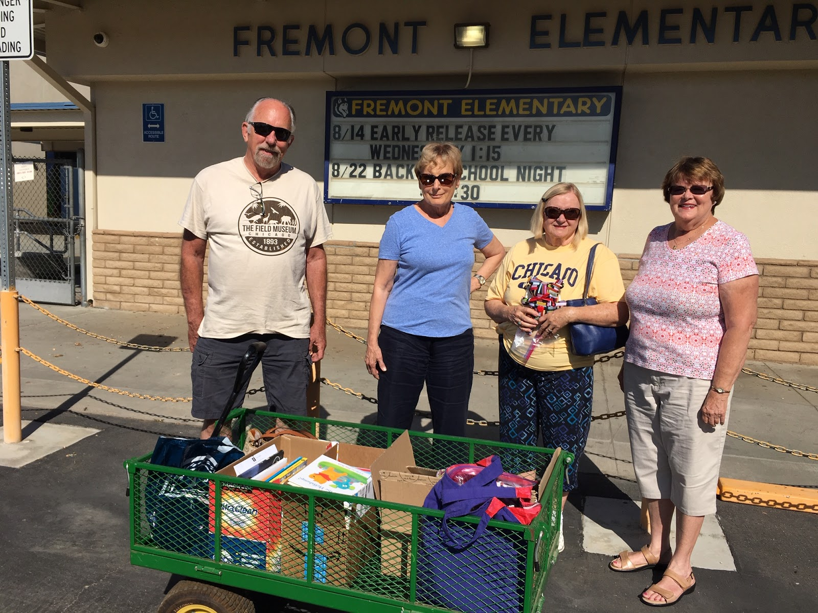

AAUW Members with Teachers at Liberty School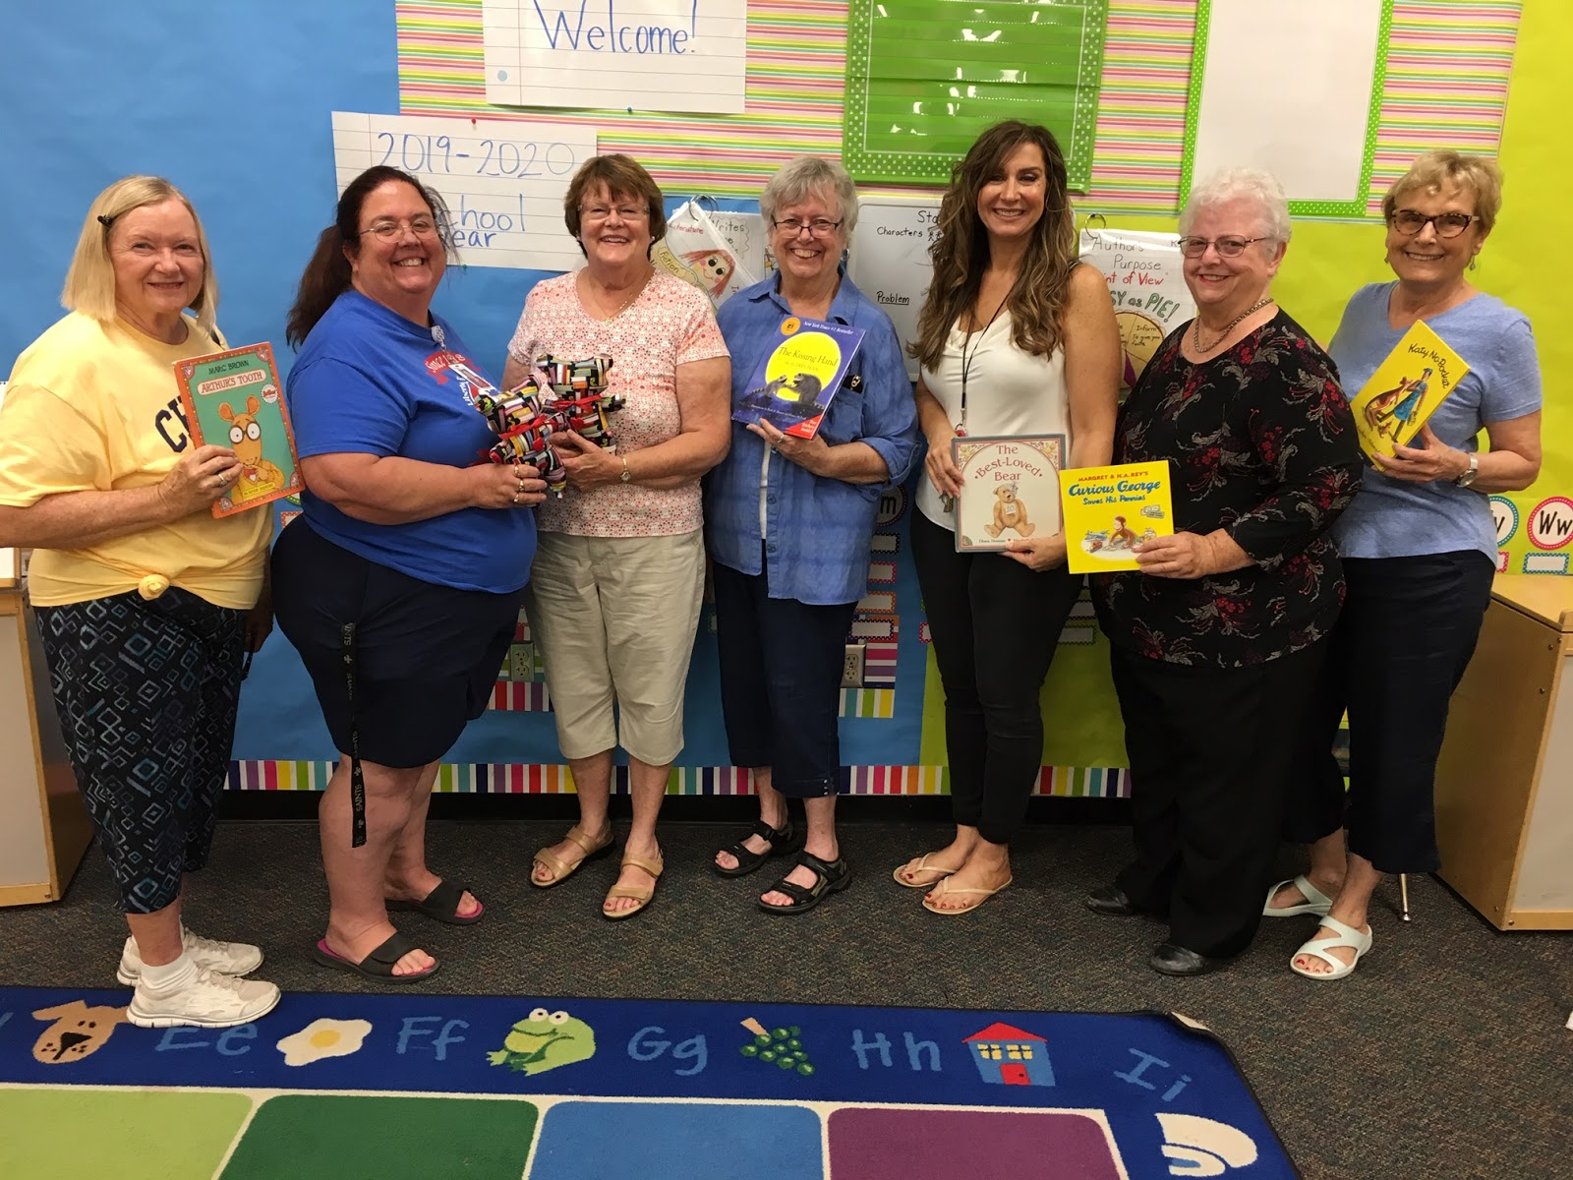

AAUW NATIONAL SPOTLIGHT

More Equal Pay Wins Cap Off Blockbuster Year
This year brought increased focus on the gender pay gap and ways to close it. As a result, we saw tremendous activity, with a record-breaking 11 states, not to mention numerous additional localities, enacting legislation to address pay equity in 2019. This is a significant uptick from 2015, 2016, 2017 and 2018.
Here are a few highlights: After fighting for years, and with the help of AAUW of Illinois members, Illinois successfully updated their law to include a ban on using salary history during the hiring process, a practice that can carry forward past pay inequities. The law also adds a provision narrowing the reasons employers can use to justify a pay difference. Similarly, both New Jersey and Toledo, Ohio passed salary history bans. New Hampshire would have joined the list, but Gov. Chris Sununu (R) vetoed the state’s bill to ban the practice. Read more about these and other state-level equal pay victories from 2019 in our annual round up blog.

LEGISLATION
Oregon Joins Seven Other States and DC in Enacting Paid Family and Medical Leave
Oregon became the most recent state to enact a paid family and medical leave bill, when Gov. Kate Brown (D) signed the most expansive bill in the country into law on August 9. AAUW of Oregon members were part of the coalition advocating for the law, which will go into full effect in 2023. The new law applies to a wide range of care needs and features an inclusive definition of family; covers everyone who works for an employer with one or more employees, as well as an option for self-employed workers to opt-in to the program; provides job protection to all workers; and offers progressive wage replacement that includes 100 percent wage replacement for the lowest-wage workers.
Oregon joins Connecticut in passing a new paid family and medical leave law in 2019, as well as six other states and Washington, D.C. that previously passed this type of legislation. New research tells us the importance of these laws to families, and how to implement them effectively.

TIPS

Sign Up to Receive AAUW’s Cutting-Edge Newsletter
Want to be a Washington insider and stay informed about legal and policy developments across the country? Sign up to receive AAUW’s Washington Update newsletter. Published every week that both chambers of Congress are in session, Washington Update offers insight into the legislative and executive branch process, the latest public policy news, crucial and timely action items, and updates from the AAUW Public Policy and Research Department.
RESOURCES

Updated AAUW Pay Equity Resources
With so many states passing laws designed to close the gender pay gap, it’s useful to stay informed about new provisions and identify which crucial workplace protections are still missing. We refreshed AAUW’s comprehensive guide to equal pay in the states at the beginning of the month to help. Use it, and our state-specific policy guide roadmaps, to educate yourself and prepare for the upcoming legislative sessions. Then look out for even more updates to these resources at the end of September once the U.S. Census Bureau releases new data. In conjunction with AAUW’s other advocacy tools, you’ll be ready to talk to your elected officials about how to close the gap.

Women’s Treaty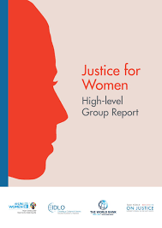

Every Woman Needs A Good Treaty. Here Is One With The Potential For Some Real International Clout

Lenore Gallin, Member International Advocacy Subcommittee Program Committee international@aauw-ca.org In March 2019 I had the privilege of being an AAUW delegate to the sixty-third session of the United Nations Commission on the Status of Women (CSW) at UN Headquarters in New York. This year’s themes were social protection systems, sustainable infrastructure for gender equity, and empowerment of women and girls. What a thrill to find the UN filled with women from all over the world in their colorful national clothing, the corridors resonating with sounds of exotic languages and the plenary session beginning with a round of songs sung by delegates overcome with joy and nostalgia. It was exhilarating to experience such an incredible sisterhood, to find knowledge and support and friendship in unfamiliar places, to generate stories we would take home to remember for always. CSW was established as part of the UN in 1946. It laid the groundwork for four World Conferences on Women, orchestrated social action campaigns, and continues to weigh in on international issues affecting women and girls. The annual meeting provides opportunities for non-government organizations (NGOs) to interact with member states. This year 490 parallel events were organized by NGOs working on behalf of women all over the world. One of the most interesting and provocative of the parallel events was the presentation of the Every Woman Treaty. This Treaty is an ambitious global initiative designed by a consortium of experts on sexual violence and gender equality from 128 countries, in concert with recommendations from the UN and the World Health Organization. Currently, there is no legally binding convention at the global level to hold nations accountable for preventing violence against women and girls or helping victims survive and heal. This is what makes the Every Woman Treaty so unique and important - it develops a legal framework that holds nations responsible for violence when it occurs on their watch. Experience teaches that problems of this magnitude require the force of binding legal treaties. The Mine Treaty, for example, garnered 500 million dollars immediately after its signing in 1997 and was able to clear landmines from millions of acres of fields, saving countless lives in multiple nations. I believe the Every Woman Treaty can do the same for women and girls, by requiring signatory nations to adopt strategies to enact and enforce laws, train personnel, educate the public, and provide services to ensure survivors of violence receive treatment, protection, and avenues for seeking justice. Treaties also have the potential to catalyze funding. Toward this end, the Every Woman Treaty aims to raise four billion US dollars annually or one dollar for every female on earth. The Every Woman Treaty is supported by a coalition of more than 1,700 women’s rights advocates, including 840 organizations, in 128 countries. It offers every woman and man a chance to get involved.

END

