American Association of University Women –
Riverside/ /Moreno Valley/ San Gorgonio Branch
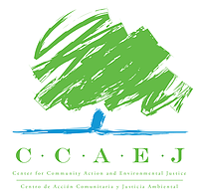
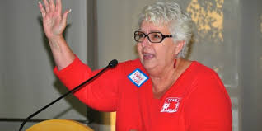
Presents
Penny Newman, Executive Director
Center for Community Action and Environmental Justice
WHERE: HABITAT FOR HUMANITY, 2180 IOWA AVE, RIVERSIDE AT 10:00AM, WEDNESDAY OCTOBER 5, 2016
LUNCH TO FOLLOW FOR THOSE INTERESTED AT THE MEXICALI GRILL, 1690 SPRUCE ST.
RSVP TO LUISA TASSAN 951-742-5479 OR Dewaelri@aol.com
What does the Ag Park-Riverside, Goods Movement Campaign, and Love Canal all have in common---the leadership and activism of strong persistent women. Scholars have come to call these women part of the “eco-feminist movement” and Jurupa Valley’s own Penny Newman has been attributed as one of its’ earliest founders. Through the work of her CCAEJ which organizes to promote environmental justice in low income areas where those most impacted by environmental health hazards live---she advocates for policies at the state, regional and local level that protect public health. She has been on the Oprah Winfrey show, the subject of an HBO documentary and honored by various groups from the CA State Senate to the CA State museum and our own Chamber of Commerce & YWCA.

